Accomplishments Dashboard User Guide

The Accomplishments Dashboard provides a comprehensive summary of weekly individual achievements across different workstreams and contractors. Below is a step-by-step guide to understanding and utilizing this dashboard.

# 1. Filtering Options

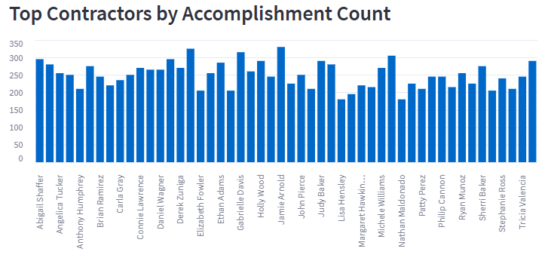

Users can filter the accomplishments data using:  
- Reporting Week  
- Contractor  
- Workstream  
- Keyword search in accomplishments

# 2. KPI Summary

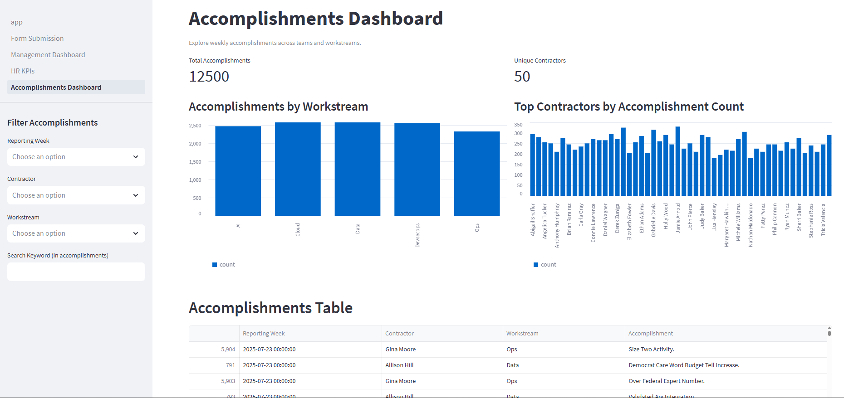

This section displays the total number of accomplishments and the number of unique contributors.

# 3. Accomplishments by Workstream

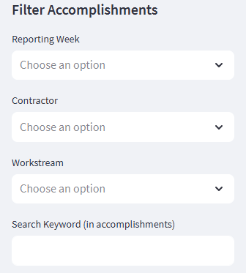

Visual breakdown of accomplishments categorized by each workstream.

# 4. Top Contractors by Accomplishments

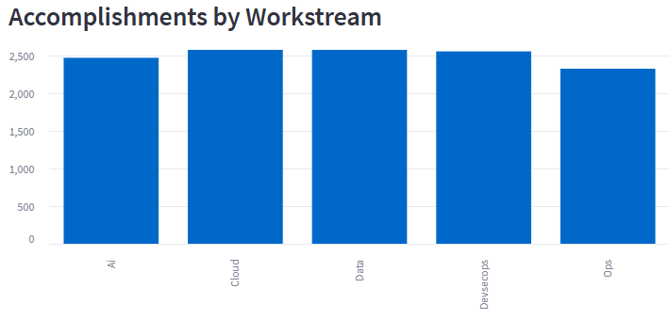

This bar chart highlights contractors who contributed the most accomplishments.

# 5. Accomplishments Table

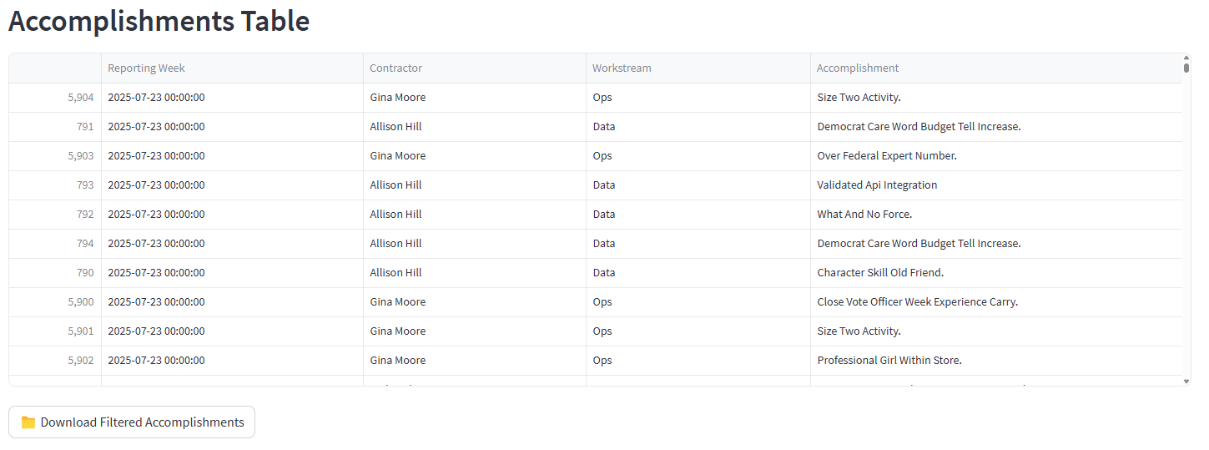

A tabular view of detailed accomplishments, including contractor names, workstreams, and descriptions.

# 6. Download Filtered Results



Users can export the filtered accomplishments as a CSV file by clicking this button.